**THE DEVELOPMENT OF WEB-BASED INQUIRY SYSTEM**

**FOR STI COLLEGE OF ALABANG**

**A Thesis Project Presented to the**

**Faculty of the Information Technology Program of**

**STI College of Alabang**

**In Partial Fulfillment of**

**the Requirements for the 2nd Year of**

**Bachelor of Science in Information Technology**

**Calinog, Josh Raizen A.**

**Magante, Keith Izam N.**

**Mangampo, Vince Ivan N.**

**Pascua, Jermaine Angelo S.**

**TABLE OF CONTENTS**

**Page**

**Title Page i**

**Table of contents ii**

**Chapter 1 1**

**1.0 Introduction**

**1.1 Background of the Study**

**1.2 Statement of the Problem**

**1.2.1 General Problem**

**1.2.2 Specific Problem**

**1.3 Objective of the study**

**1.3.1 General Problem**

**1.3.2 Specific Problem**

**1.4 Significance of the Study**

**1.5 Scope and Limitation of the Study**

**Chapter 2 2**

**2.0 Literature review**

**2.1 Review Related Literature**

**2.2 Synthesis**

**Chapter 3 3**

**3.0 Conceptual paradigm**

**3.1 Project Management**

**3.1.1 Data Gathering Procedure**

**3.2 System requirements**

**3.2.1 Hardware requirements**

**3.2.2 Software requirements**

**3.3 Flow Chart**

**3.4 Human resources**

**Chapter 4 4**

**4.0 References**

**4.1 Appendix**

**Chapter 1**

**1.0 Introduction**

Technology advances over time and has become an indispensable part of people’s daily lives. It can be said that the usage of modern technology has become the very foundation of any business, personal use, or education. Developers can use modern technology to create new software capable of processing data in seconds. It can also be used to create solutions that humans have never thought of modern technology has transformed the business landscape, offering numerous benefits that boost efficiency, productivity, and overall competitiveness.

What's wonderful about modern technology is that developers can create software that connects people regardless of distance by sending messages and starting video meetings on users' devices Anderson, J. (2018, July 3). Users do not need to leave their homes to send messages or start meetings; instead, they can use their devices to save time and effort. Businesses or other organizations use an Inquiry System to connect with people and answer their questions, and to let people find or search their needs. An Inquiry System is a comprehensive and dynamic platform designed to manage and streamline the process of handling inquiries within an organization. Whether applied in an educational institution, business, or any other setting, an Inquiry System serves as a centralized hub that efficiently handles incoming requests, questions, or information-seeking interactions EduSec (2020, December 3). Inquiry Systems have a significant impact on organizations, revolutionizing the way inquiries are handled and contributing to overall efficiency, transparency, and customer satisfaction. These systems have far-reaching consequences in a variety of industries, including education, business, and service-oriented organizations.

Users do not need to be concerned about security because the developer's top priority is to protect personal accounts and data from threats such as Malwares, which refer to a wide range of malicious software that can enter the systems and breach confidential data, or Phishing attacks, which are carried out via emails and other communication channels. It can trick users into sharing access credentials such as passwords, PINs, and other vital information, giving hackers access to the data or account.

Inquiry Systems are transformative, giving organizations the tools, they need to streamline processes, improve communication, and adapt to the changing needs of their users. Whether in education, business, or service-oriented sectors, the implementation of these systems contributes to a more efficient and user-centric organizational environment.

**1.1 Background of the Study**

Significant changes in a variety of sectors, particularly education, have resulted from technological advancement. The introduction and widespread adaptation of Inquiry systems to various industries is one notable development. Inquiry systems can bridge the communication gap between users and administrators by allowing them to find information, concerns about a specific topic, and find valuable information.

The proponents have decided to build a School Inquiry system to inform the students of STI College of Alabang about the latest School products as soon as possible. This system's goal is to show the available stock of school products, to enable students to submit a Reservation form if they want about the school products, and to develop an inventory management system that organizes the availability of the products. Staff working at the Proware office may use this system to inform STI College of Alabang students about the most recent school products available and students can view the most recent school products available.

To summarize, staff and students can benefit from using this system because it streamlines the process of handling inquiries and allows administrators to address questions or concerns about school products more efficiently. Another advantage is that students will have easy access to detailed information about available school products, such as pricing, sizes, and product descriptions. This ease of access aids in making informed purchasing decisions.

**1.2 Statement of the Problem**

This study aims to develop a web-based inquiry system that seeks to address the following existing problems: (1) students must visit the Proware office multiple times to find out the available school supplies. (2) Lack of information and dissemination to students on the availability of school products in the Proware office. (3) Due to limited available stocks in the Proware office and the administration's lack of data on the demand for certain school products, some students are unable to get certain products.

**1.2.1 General problem**

The general problem of this study is the development of a web-based inquiry system for both students and administrators of STI College of Alabang that allows them to view, inquire, make reservations for students, and manage stock inventory for administrators. This system will help the staff be more efficient in the overall management of Proware Office and improve the overall student experience.

**1.2.2 Specific problems**

* How to develop a simple and consolidated user interface that allows students to visually acquire information about the different school products?
* How to develop a log-in module that allows users to access the system?
* How to develop an admin dashboard where administrators can manage the school's products' inventory and students' reservations?
* How to develop a reservation form that allows students to make a reservation for their desired product?
* How to develop an inbox module that notifies students about their reservations?
* How to develop a print function that allows administrators to save and print the product update data (product number, name, quantity, price, and update type) of all the school products in the system.

**1.3 Objectives of the Study**

**1.3.1 General objective**

This study aims to develop a web-based inquiry system that will allow students and administrators to view, inquire, make reservations for students, and manage stock inventory for administrators, which will help the staff be more efficient in the overall management of Proware Office and improve the overall student experience.

**1.3.2 Specific objectives**

* To develop a login that allows the student to access the system.
* To develop a simple user interface
* To develop an admin dashboard wherein the admin can manage the school products, reservations, and inventory.
* To develop a reservation form that allows the student to acquire secure products.
* To develop an inbox module that notifies students about their reservations.
* To develop a printing function of the records for the administrators’ documentation.

**1.4 Significance of the Study**

The researchers focus on the inquiry system of STI College of Alabang, which will benefit the following:

* **Students**

Every student will benefit from this system, which allows them to search for information online about school supplies. Students will receive updates regarding the information provided by this system regularly.

* **Proware office (Administrators)**

The proware office will benefit from this system's ability to effectively handle available school supplies and inform students about their inquiries.

* **STI College of Alabang**

The school will benefit from this system by increasing productivity and service quality, so the school can also benefit from it.

* **Researchers**

This system will benefit the researchers; it will expand their understanding of programming and development and improve their problem-solving skills.

* **Future researchers**

This system will be beneficial to future researchers, who might use the findings as a foundation for developing their own system.

**1.5 Scope and Limitation of the Study**

This system focuses only on improving the procedure of the students’ inquiries. For that reason, this system aims to help the students to inquire in an effective/efficient way.

**1.5.1 Scope of the study**

* **Registration Module**

The system requires this module to fill up to determine whether they are a student at the school to access the system.

* **Login Module**

The system requires the student and administrators to log in to the system to access the system.

**Student Module:**

* **Dashboard Module**

The students can acquire important information through viewing or searching the school products, such as uniforms, key chains, organization shirts, anniversary shirts, event shirts, and other products.

* **Student Reservation Form**

The students may send a reservation form to have their products secure until they get their reserved products such as uniforms, organization shirt, and event shirt.

* **Inbox Module**

The student can receive a notification in the inbox module regarding the approval or rejection administrators of the reservation.

**Admin Module:**

* **Dashboard Module:**

The administrator can monitor the statistics such as total products, page view, total stock of products, and total reservations.

* **Inventory Module:**

The administrator can track and manage the available school products. The administrator can also provide real-time information on the availability of school products, enabling the students and staff to monitor product stock.

* **Product Records Module:**

The administrator can view the overall product records including the changes in product information.

* **Reservation Module:**

The administrator may accept or decline a reservation form depending on the availability of school products and undo a rejected or approved reservation.

**1.5.2 Limitations of the Study**

* The system can cover school products provided by a particular provider.
* The system is compatible with desktop, laptops and smartphones.
* When making reservations, students can give incorrect or incomplete information, which could cause misunderstandings or cause a delay in receiving a response.
* The system can provide visual inquiry for inquiries such as viewing or searching for the information they need.
* The System can be accessed without the internet.

**Chapter 2**

**2.0 Literature Review**

**2.1 Review of Related Literature**

This chapter includes the ideas, generalization, conclusions, and others. The purpose of this chapter is to provide familiarization with information that is relevant and like the present study.

**Local Literature**

● According to Caratiquit (2021), a web-based school information system is both valuable and effective. Caratiquit noted in his study using the iterative water software methodology, that a web-based school system would benefit the teachers, staff, students, and parents in receiving timely and correct information, which can be accessible from any device whenever, wherever. Using a survey of 558 respondents that includes teachers, non-teaching staff, students, parents, and IT professionals, Cartiquit was able to evaluate the developed study based on ISO 25010:2011 software quality standards. His method of developing the system followed three phases namely requirements, design, implementation, verification, and maintenance. At the end of his study, he was able to conclude based on the survey responses that the system created has all the functions needed, the system was easy to understand, and it was efficient in providing accurate information needed by users.

● In the words of Secretaria, et al, (2021), young consumers in the Philippines have a high trust on online purchasing. It was also stated that customers have higher purchase intentions to shops that offer fast delivery time, with responsive customer service, and are accessible to both web and apps. The research used a survey questionnaire conducted in Cebu, Philippines with 50 respondents with the objective of analyzing the behavior and trust of consumers when using online for reservation and purchasing transactions. The study recommends that online services should focus on providing fast and reliable transactions.

● Baran, et al (2021) focused on Major Functionalities and Modules of the e-school system they designed through its implementation methodology which is the Agile Model and its impact on the delivery of services and procedures in the overall operation in their community College in Northern Mindanao. The objective of the study is to create a centralized system in storing, processing, retrieval, and generation of school data, which will provide ease to the school personnel and will diminish if not, lessen the paperwork’s aligned to school transactions. The system has been evaluated as Functional, Usable, and Reliable based on ISO 25010; a quality model used for product/software quality evaluation systems. Web-based inquiry systems must be properly researched and matched to the needs of those who will be using them. Web based systems designed and developed based on needs will enhance the transaction process and benefit those who are making use of the system, Baran, et al, (2021).

● According to Clarin & Lumauag (2019), once the effectiveness of the web-based system is confirmed for those who will be using it, was assessed by IT Professionals, and is ready to use, an orientation must be conducted on how to use the system before they implement it. This is to ensure that the target users are aware of the benefits, interface and limitations of the web-based system which will equip them on how to use it.

● It has been allocated that innovation is all along our country, even on the whole world. Nevertheless, in our country, it still holds that innovation regarding the inquiry system by deliberating information and specific tools or material for students is significant. According to Maggay (2019), one of the responsibilities of registrar along the university is to record, list, and store data. By this, the initial way or easiest way to conduct their work is to define an inquiry system basis which an automatic system will access various inquiries that can make their occupation more innovative. Furthermore, the system should be designed to be secure and to protect confidential information. Finally, the system should be able to be updated to ensure that it is always up to date with the latest technologies. By taking these steps, registrars can ensure that their inquiry system is as innovative as possible. To further increase innovation in the inquiry system, Maggay (2019) developed a system that is compatible with the needs of his university as well as their province. Noting that Internet services are not accessible to some areas in their province, Maggay developed an inquiry system that is SMS based. The development of the system was guided with the Waterfall Model following the five different phases such as Requirements Analysis, System Design, Coding and Module Testing, Integration and System Testing, and Deployment and Maintenance. As a result, InquiText can automatically respond to the clients’ inquiries on grades and accounts.

**Foreign Literature**

● According to (Jiménez-Liso et al., 2022) inquiry is considered as a teaching approach consisting of tasks that pursue concrete instructional objectives. In their study they were able to identify how inquiry starts with a question that engages the other person and then leads to gathering data.

● Yasin et al, (2021), shared on research they have conducted in the design and development of web-based inquiry as an online science inquiry environment, web-based inquiry can be used for both teacher and students in appropriate content navigation and layout. In their study they used the development of a 4-D model for learning tools in creating the web-based inquiry system which has four main stages: Define, Design, Develop and Disseminate. This method and model were chosen to produce web-based inquiry products. Yasin et al, (2021) used a Web Evaluation Questionnaire answered by junior high school teachers to assess if the inquiry system has the appropriate features and workflow. They were able to conclude that a web-based inquiry system is well received if it has the appropriate content, easy navigation, and good web appearance.

● As for the management or web owner’s side, according to Sydoruk (2023), web-based systems and applications make their lives easier as they can access the data they need anytime, risk of data loss is reduced and speeds up development throughout the process. When one transfers from traditional face-to-face transaction to online, they experience efficiency as data is accessible 24/7 and has no geographical restrictions. One does not need to be physically present in the store to inquire about or reserve the service. It can be easily checked and browsed online.

● Alkhaldi, et al (2018), developed a reservation system using the Unified Modeling Language (UML), MySQL and visual basic (VB) programming language. Their study explores the probability of resolving the issues in reservation and management of school facilities. Their motivation in developing the system is that their school does not have a reservation system online which limits the learners as well as the faculty members. With an online reservation system, the University facilities will be maximized as it will be easier for the students and faculty to check the availability online as well as to input reservations. In the interface design, they ensure that it caters to all types of users and is user friendly. The proposed reservation site starts with the welcome page and then the user proceeds to the login process if he or she has an account already. If not, the user must proceed to the user registration process and fill out the necessary information. Once logged in the user will now be shown facilities for reservation. The development and implementation of the system has resolved the imbalance in usage of the facilities in the university as it provides real time data on availability and allows users to reserve wherever they may be.

● An automated program that operates on your front line to ensure that each new inquiry is given the attention it requires is called an inquiry management system. For sales teams to respond, inquiries are methodically tracked, recorded, and managed. If an educational institution lacks a comprehensive system to collect student data and a well-knit marketing strategy, achieving enrollment targets can be a tough and taxing endeavor. Sorting through and arranging this kind of data is a difficult operation that takes a lot of time, energy, and resources. Furthermore, it's possible to lose prospective leads or get duplicate leads, both of which are undesirable. But with the help of the reliable and methodical student inquiry management system, this procedure runs more smoothly, quickly, and efficiently. It assists the institutions in making more cost-effective and lucrative use of their resources. Specifically, this study based on Ahmed (2022) defines what are the primary impacts and significance of having an inquiry system among universities, campuses, and institutions. It signifies that methods and procedures along with selling and marketing school or university products could be effective when inquiry systems are applicable.

**2.2 Synthesis**

Most literature reviews agree that the inquiry system is beneficial or efficient in terms of searching for information, especially in schools, hospitals, etc. The purpose of the Inquiry system is to improve the quality of searching for information that the user needs. It helps to improve the management system. For this outcome to be achieved, thorough research, or study, and a well-developed system is essential. Taking this into consideration, a thorough research study is implemented by the STI College of Alabang’s’ proponents. This study forms the needs for the Inquiry system that would facilitate information gathering and improve productivity.

In conclusion, the process of forming this documentation has been thoroughly planned and the data or information that has been gathered by the proponents in this study on different related literature, and research has been applied to improve the quality of the Inquiry system of STI College of Alabang.

**Chapter 3**

**3.0 Conceptual Paradigm**

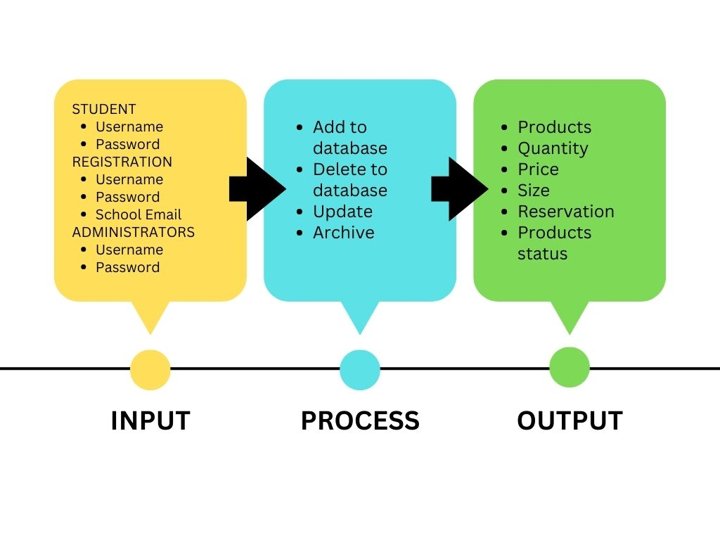**Input Process Output**

**Figure 1:** Diagram of the Conceptual Paradigm of the study.

According to the conceptual paradigm of the study **(Figure 1)**, the researchers developed a web-based inquiry system to be utilized by the administrators in the Proware office and students of STI College of Alabang. After that, the researchers interviewed the administrator in the Proware office to gather feedback about the web-based inquiry system.

**The Input**

This module consists of the major component of the information needed in the system: the information of the students such as username, password, and school email address. These inputs are necessary to gain access to the system.

**The Process**

The processes that must be carried out to satisfy the requirements are covered by the system's process module. It involves system management tasks like updating the school products and adding, removing, and managing data in the database.

**The Output**

It refers to the result or outcomes of the system's process of displaying the products and their status, the details or descriptions of the products, and the reservations.

**3.1 Project Management**

**3.1.1 Data Gathering Procedures**

The data required to create the research study were gathered and collected by the researchers. Different methods have been used to gather data to achieve the goals.

**Interview**

The researchers looked for a client that we may ask questions. After acquiring a client, they scheduled an interview with Ms. Hanna M. Sespeñe, STI College of Alabang’s proware staff. The researchers acquired information they needed to develop an Inquiry System. The researchers conducted an interview to achieve the needed information for the progress of the study.

**Internet Research**

The researchers searched for a client with whom the researchers could ask for an interview. Following their selection of a client, the researchers arranged an interview with Ms. Hanna M. Sespeñe, the proware staff of STI College of Alabang. The information gathered by the researchers was necessary to develop an inquiry system. To gather the data required for the study's progress, the researchers conducted an interview.

**3.2 System Requirements**

**3.2.1 Hardware Requirements**

* CPU: Inter Core i3 – i5 or more preferred 3rd generation or more preferred.
* Graphics Card: 256 MB minimum, 2 GB or more preferred.
* RAM: 2GB, or more preferred.
* Storage: 16GB, or more preferred.
* Keyboard: Standard Windows Keyboard
* Mouse: Two or more Button Mouse
* Monitor: SVGA

**3.2.2 Software requirements**

* Operating System: Windows
* Technology: HTML/CSS/JAVASCRIPT/PHP
* IDE: Visual Studio Code
* Web Server: XAMPP
* Database: MySQL

**3.3 Flow Chart**

**Login**

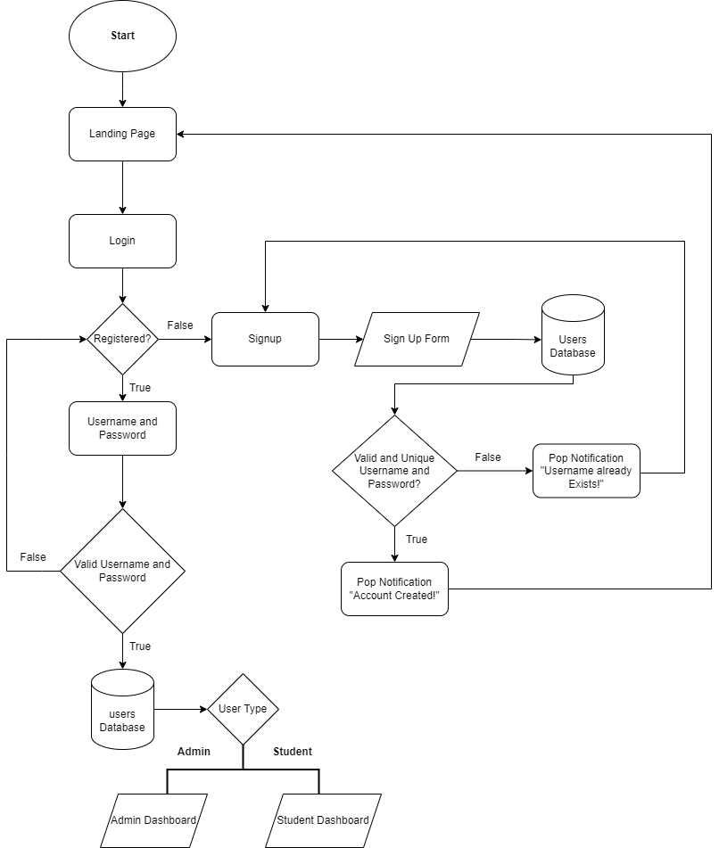

**Student/Administrators**

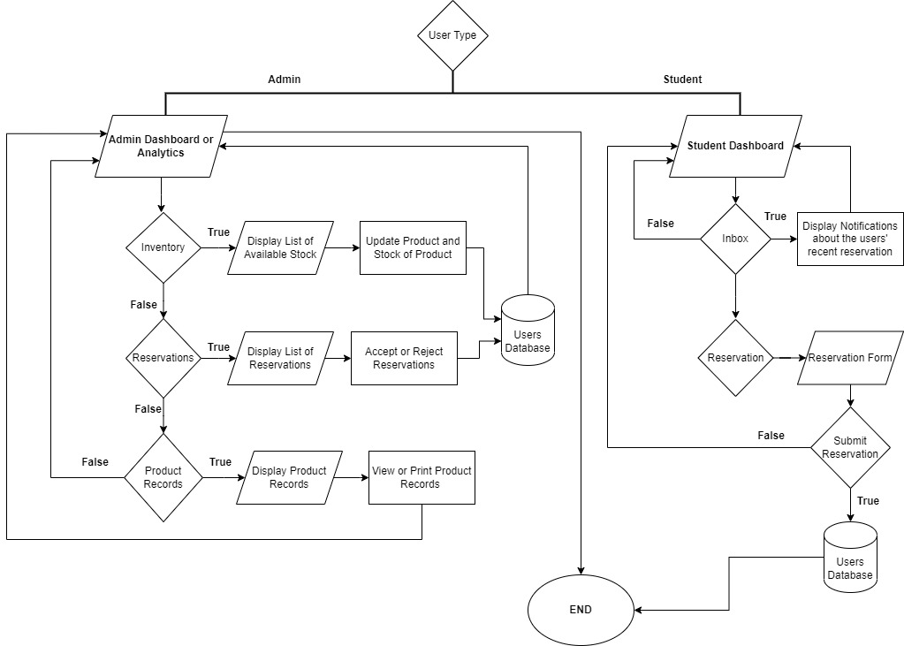

**3.4 Human Resources**

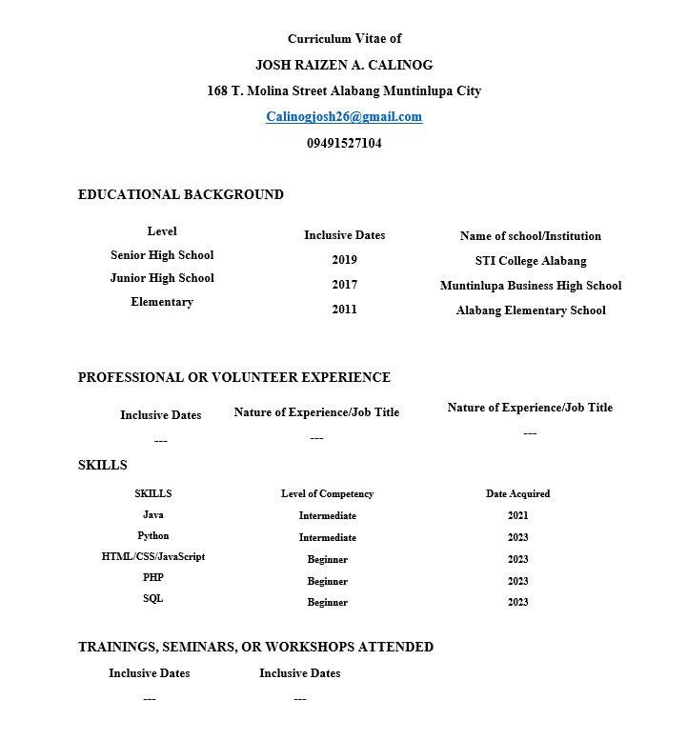

**Chapter 4**

**4.0 References**

Ahmed (2022). Student Inquiry Management System Software for Hassle Free Student Enrollment.

<https://www.iitms.co.in/blog/mastersoft-student-enquiry-management-system.html>

Alkhaldi, D., Aldossary, A. S., & Alrajhi, D. (2018). Developing and implementing web-based online university Facilities reservation system. *ResearchGate*. <https://www.researchgate.net/publication/330841416_Developing_and_Implementing_Web-based_Online_University_Facilities_Reservation_System>

Anderson, J. (2018, July 3). 1. the positives of Digital Life. Pew Research Center: Internet, Science & Tech.

<https://www.pewresearch.org/internet/2018/07/03/the-positives-of-digital-life/>

Caratiquit, K. (2021b). Web-based school information and publication System: a developmental study. *ResearchGate*.<https://www.researchgate.net/publication/354006016_Web-based_School_Information_and_Publication_System_A_Developmental_Study>

Clarin, J. A. (2020b). Web-Based Information System Portal with SMS support for Aklan State University-Kalibo Campus. *ResearchGate*. <https://www.researchgate.net/publication/343205629_Web-Based_Information_System_Portal_With_SMS_Support_For_Aklan_State_University-Kalibo_Campus>

EduSec ERP. EduSec. (2020). Benefits of Inquiry Management System

<https://www.edusec.org/blog/benefits-of-inquiry-management-system.html/>

Maggay, J. (2019). InquiText: SMS-Based Auto-Reply inquiry system for grades and accounts. *ResearchGate*. <https://www.researchgate.net/publication/334537821_InquiText_SMS-Based_Auto-Reply_Inquiry_System_for_Grades_and_Accounts>

Grepon, B. G. S., Gumonan, K. M. V., Baran, N., & Lacsa, M. L. (2020b). Designing and Implementing e-School Systems: An Information Systems Approach to School Management of a... *ResearchGate*. <https://www.researchgate.net/publication/349380908_Designing_and_Implementing_e-School_Systems_An_Information_Systems_Approach_to_School_Management_of_a_Community_College_in_Northern_Mindanao_Philippines>

Secretaria, et al, (2021). Trust and Purchase Intention on Online Shops Amid Covid 19 Pandemic: As Basis for Regulatory Policy. EPRA International Journal of Economic and Business Review-Peer Reviewed Journal. <https://eprajournals.com/jpanel/upload/1225am_4.EPRA%20JOURNALS%208480.pdf>

Sydoruk, A. (2023b, May 24). *7 Benefits of Developing a Web-based application for Your Business*. SmartTek.

<https://smarttek.solutions/blog/web-based-app-for-businesses/>

Yasin, A., Rochintaniawati, D., & Prima, E. C. (2021). The development of web-based inquiry as an online science inquiry environment. *Journal of Physics: Conference Series*, *1806*(1), 012141.

<https://doi.org/10.1088/1742-6596/1806/1/012141>

**4.1 Appendix**

**Landing Page**

* **Home Module**

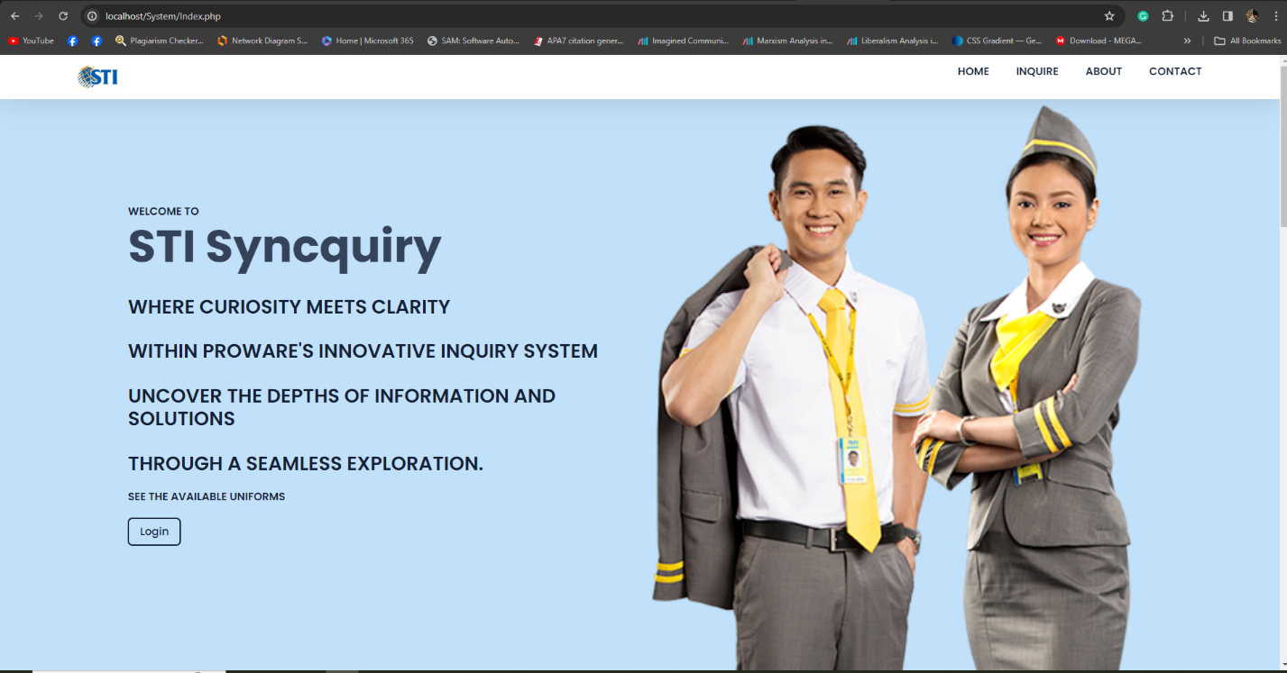

* **Contact Module**



* **About Module**

* **Register Module**

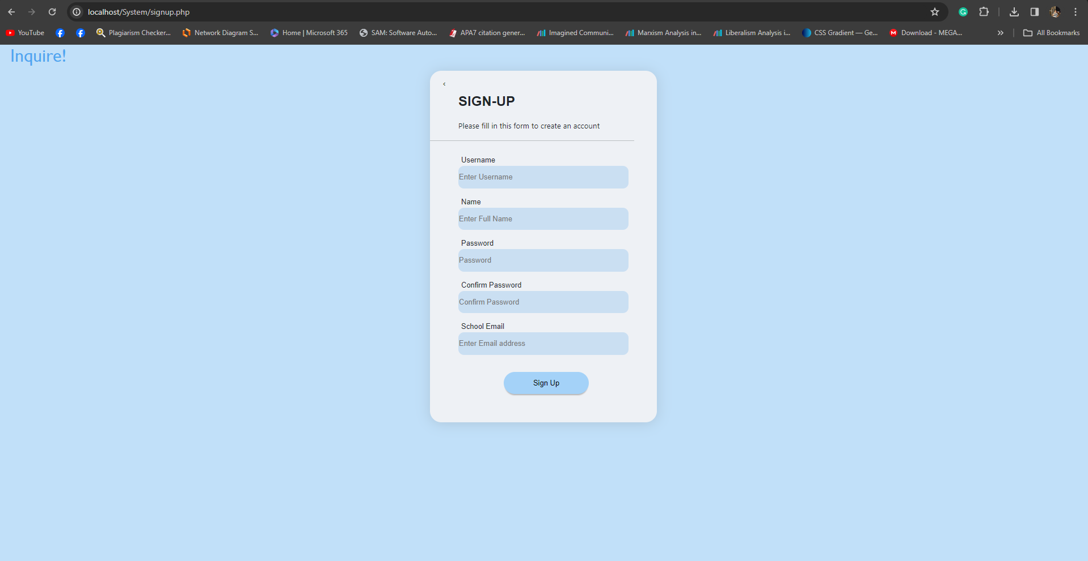

* **Login Page**

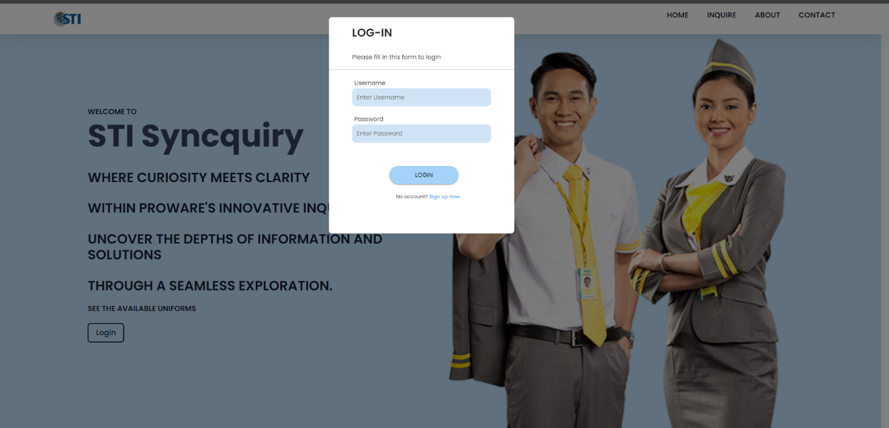

**Administration Module**

* A screenshot of a computer

  Description automatically generated**Administration Dashboard**
* **Inventory Module**

* 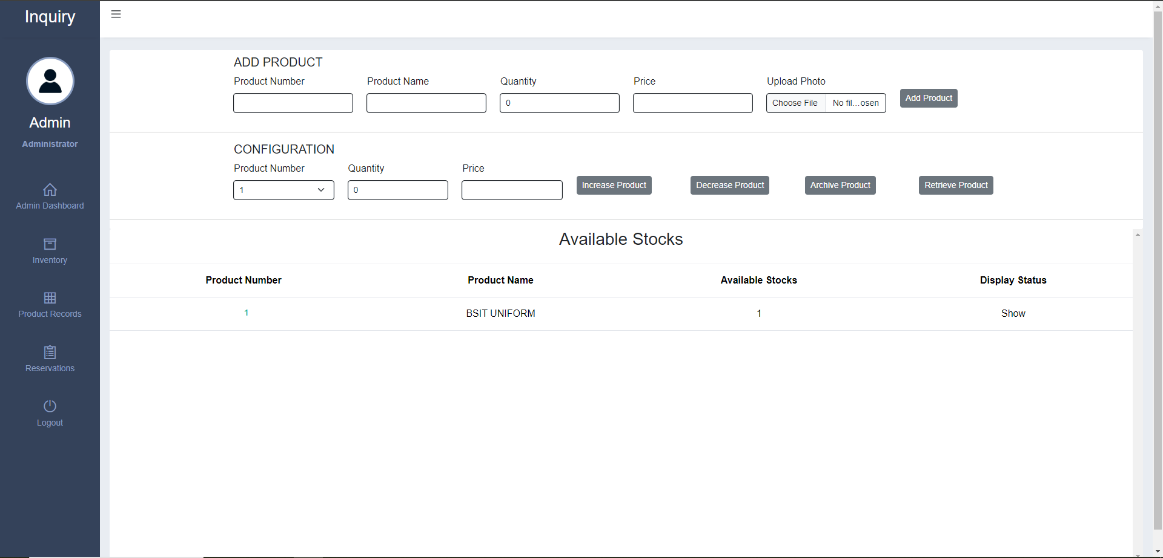**Product Records Module**
* **Print Function**

* 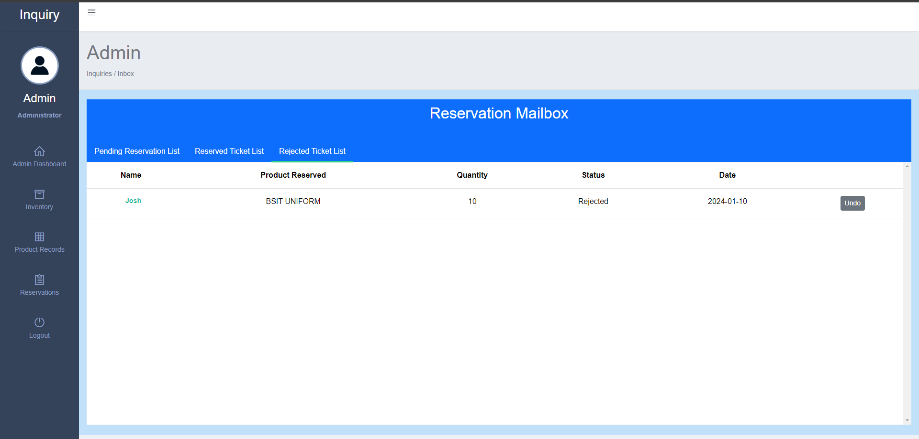**Rejected List**
* 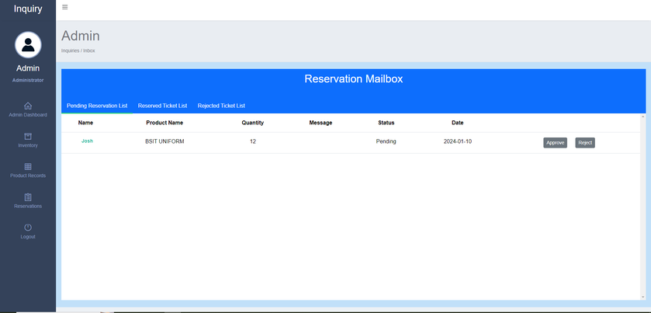**Pending List**
* **Reserved List**

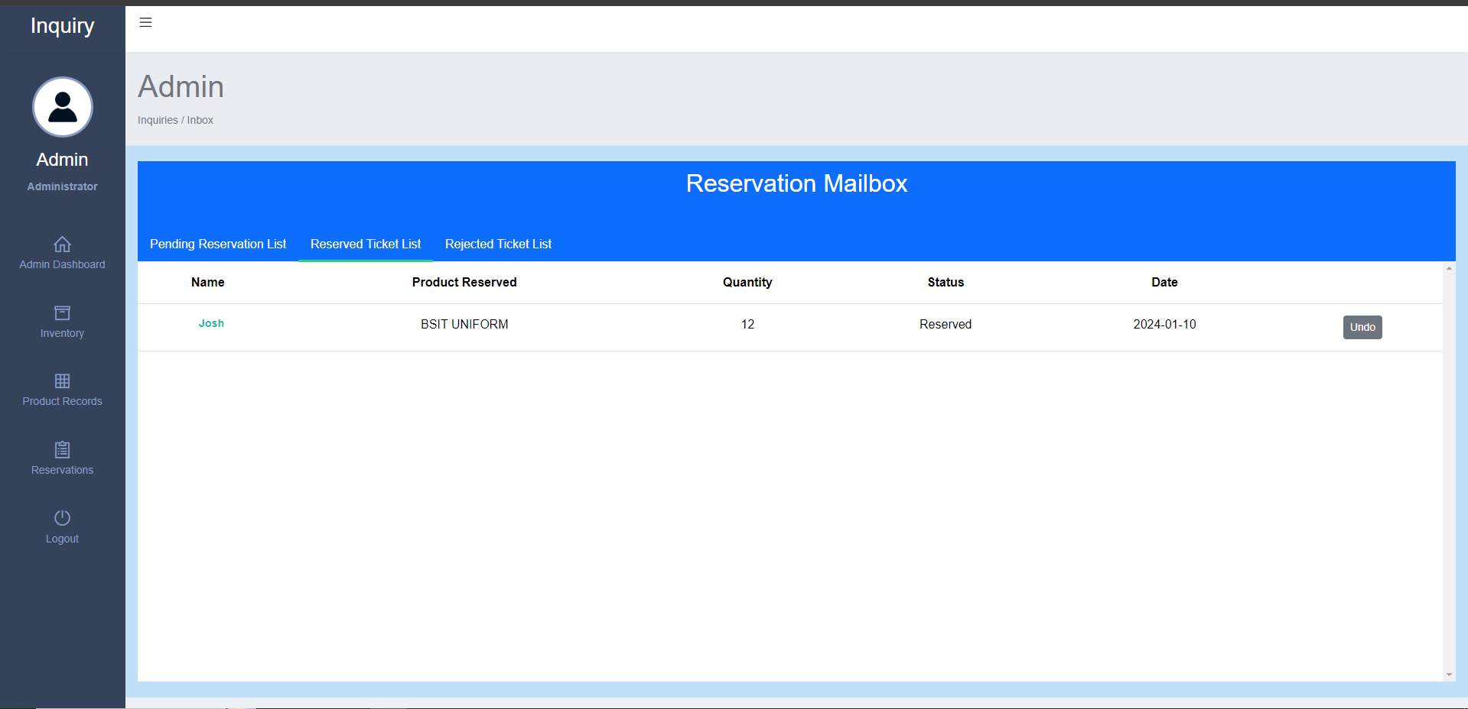

**Student Interface**

* 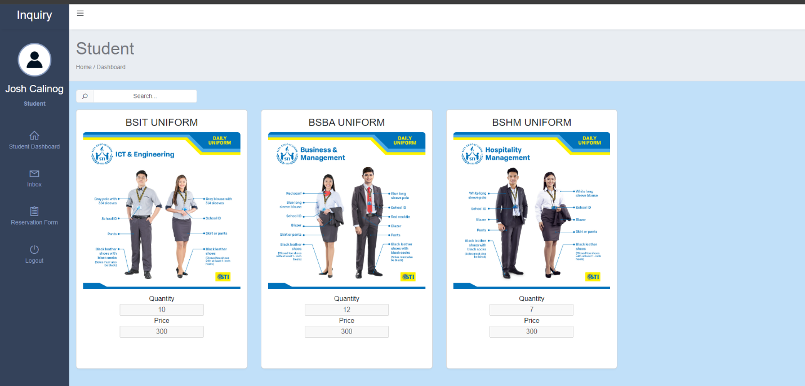**Home Dashboard**
* **Mailbox**

* A screenshot of a computer

  Description automatically generated**Reservation Form**

**Transcript Interview**

1. What are your methods when handling or updating the number of stocks like do you have a certain software that you use?

**Answer:** We don’t have any system for handling number quantities of stocks we use logbooks they can't post the products with pictures including the prices since it is confidential

2. What kind of system do they want in their case?

**Answer:** We seek out for inventory manage system since we do everything manually from counting and checking.

3. Does catering many students asking about stocks gives you hard time?

**Answer:** It is too much work when every question is about stocks of certain products, and we have to manually check out inventory.

4. Do you need a reservation and what kind of reservation system do they want?

**Answer:** We don't need a reservation since there is a problem in supplier of products that reservations lead to refunds.

5. Do you have any other way to notify us students about the latest merch introduced by STI College of Alabang?

**Answer:** No, we don't have a system that can post about product with actual pic is useful.